Design Document
Hybrid AWS and on-premises infrastructure (Case study 2)
Field | Value
Author | Spartak Popov
Course / semester | Semester 5
Learning outcome | All of them
Version | <1.1>
Date | <19.10.2026>

Contents
1 Introduction and scope 4
1.1 Purpose 4
1.2 Audience 4
2 Requirements 5
2.1 Non-functional requirements 5
3 Architecture overview 8
3.1 High-level design 8
3.2 Design principles 8
3.3 Component overview 8
4 Hybrid network design 10
4.1 Address plan 10
4.2 Segmentation 10
4.3 Site-to-site VPN 11
4.4 Routing 11
4.5 Firewalling 11
4.6 Private DNS 12
5 Application and data tiers 13
5.1 Web tier 13
6 Monitoring solution 14
6.1 Overview 14
6.2 Data flow 14
7 SOAR system 15
7.1 Overview 15
7.2 Architecture and flow 15
7.3 SOAR Security 15
8 Security design 16
8.1 Identity and access 16
8.2 Encryption 16
8.3 Defence in depth 16
8.4 Secrets management 16
9 Infrastructure as Code and pipeline 17
9.1 Terraform structure 17
9.2 State and locking 17
9.3 CI/CD pipeline 17
10 Resilience and design for failure 18
11 Risks and limitations 19

1 Introduction and scope

1.1 Purpose
This document serves as a Design Document for Case Studies 1 & 2 combined. In it the improved solutions will be covered. Starting off with explaining how each requirement will be fulfilled, moving on to the architecture, the designs of the on premise network, Services, Monitoring, SOAR, Security, the pipeline, resilience and design for failure and cost estimation.

1.2 Audience
This document is written for teachers and future reviewer, as well as my future self possibly, hence I will try to make the explanations as useful as possible for readers.

2 Requirements

2.1 Non-functional requirements
ID | Requirement | Short Solution | Where it is covered
REQ-NCA-P1-01 (Network Segmentation) | The system must use a logically isolated and secure network (e.g., hub-and-spoke model) to control traffic flow and enable future expansion. | The environment uses a TGW in between the DMZ and Internal VPC | <Case description>
REQ-NCA-P1-02 (Secure Resource Access) | Some hosted services (e.g., databases) must not be exposed to the public internet and must only be accessible via secure routes (VLANs, VPNs, or internal load balancers). | Security groups filter only allowed traffic. Only the ALB is public all other services are private | <Case description>
REQ-NCA-P1-03 (Webservice Deployment) | Deploy a web service that:  Runs independently of OS-level configuration (e.g., containerized or IaC-provisioned).  Is configurable via automation tools (Terraform, Ansible). | The web instance is configured to use a launch template and nothing is set up by hand | ..
REQ-NCA-P1-04 (Scalability) | Design the web instances to scale dynamically (horizontally or vertically) for peak usage while:  Minimizing costs during off-peak periods.  Optimizing resource usage. | The ASG scales horizontally based on average CPU
REQ-NCA-P1-05 (Observability Architecture) | Implement a basic observability stack with:  Data collection (agents, exporters).  Visualization & alerting (dashboards, notifications).  Justification for monitored metrics (e.g., "CPU usage is critical for scaling decisions"). | Grafana dashboard collecting data through Prometheus from webserver instances and database for CPU usage
REQ-NCA-P1-06 (Infrastructure as Code) | Use IaC tools (Terraform, Ansible, Pulumi) for declarative provisioning of some infrastructure components (e.g., compute resources). | All AWS resources are in Terraform modules and server configuration is in Ansible
REQ-NCA-P1-07 (CI/CD for Applications & Infrastructure) | Implement automated pipelines for:  Building, testing, and deploying application updates.  Deploying infrastructure changes (IaC).  Use a self-hosted runner (GitLab Runner, Jenkins, GitHub Actions). | GitHub Actions with GitHub hosted runner  (fmt, validate, plan, apply)
REQ-NCA-P1-08 (DevOps Platform Integration) | Use a DevOps platform (GitHub, GitLab, Azure DevOps) for:  Source code management.  Deployment tracking. | GitHub for source code, pull requests and Actions.
REQ-NCA-P2-01 (Design-for-failure) | The system components deployed must be designed to ensure continued critical functionality or rapid recovery in the event of isolated hardware or software failures within infrastructure. | Two AZ for critical services. ASG replaces failed instances, RDS has Multi-AZ standby, two VPN tunnels and two DNS forwarders.
REQ-NCA-P2-02 (Network Segmentation) | The system must ensure that resources are deployed within a logically isolated and secure network environment, using a topology that allows for controlled traffic flow and future expansion (e.g., segmentation or a hub-spoke model). | Same as P1-01, but with included On-prem environment joined to the TGW through the VPN
REQ-NCA-P2-03 (Private Cloud Resource Access) | The system must ensure that components (like databases) are not directly exposed to the public internet and are only accessible from authorized networks and services through private network routes. | RDS has no public access and accepts port 3306 only from the web servers due to security group configurations
REQ-NCA-P2-04 (Internal DNS Resolution) | The system must allow resources within the virtual network to resolve service names to their private network addresses. | Route 53 private zone resolves names in the internal VPC through the default Route 53 VPC resolver
REQ-NCA-P1-05 (Automated Upgrades – Multi-Node) | The infrastructure must support centralised and automated updates for multiple systems simultaneously, using configuration management tools.  No manual actions required per machine  Consistent configuration across all nodes  Repeatable deployments | Ansible on an on-prem control node with playbooks in Git
REQ-NCA-P2-06 | Research and evaluate observability stacks for company’s monitoring needs.
REQ-NCA-P2-07 | integrate at least 2 log sources in your monitoring (e.g. firewall logs, Event logs, syslog, IDS/IPS logs) and configure appropriate alerting | pfSense firewall logs, Linux syslog/auth logs goin to Loki with Grafana alerts for brute force attacks
REQ-NCA-P2-08 (Event-Driven SOAR Architecture) | The system must include a new Security Orchestration, Automation, and Response (SOAR) capability that processes security alerts from monitored systems (on-premises endpoints/servers, and new cloud components) and triggers predefined automated actions based on event characteristics (e.g., type, severity, source). For security reasons: The work stations which are monitored should not be on the same platform as the SOAR system | Implementation of following solution: Grafata alert –> SNS –> SQS –> Lambda –> pfSense block + DynamoDB record
REQ-NCA-P2-09 (SOAR Monitoring) | The operational status and performance of the SOAR system itself (e.g., event processing rates, successful/failed automated actions) must be monitored and visualized on the central monitoring dashboard. | Grafana dashboard panels for Lambda errors, implementation, duration, SQS queue depth and successful vs failed actions
REQ-NCA-P2-10 (Infrastructure as Code) | The system must allow for the definition, provisioning, and configuration of all new cloud infrastructure components (networking, services, (container) platform etc) and the SOAR system using declarative code. | All cloud infrastructure and the SOAR are in Terraform with configuration in Ansible
REQ-NCA-P2-11 (CI/CD for Applications & Infrastructure) | The system must include automated pipelines for building, testing, and deploying updates to the SOAR components, and the underlying infrastructure definitions. These pipelines should be executable from a local runner. | The same pipeline plus SOAR Lambda tests and deployment
REQ-NCA-P2-12 (DevOps Platform Integration) | The system must utilize a DevOps platform to manage source code, pipelines, and deployments. | GitHub manages the code, pipelines and deployments

3 Architecture overview

3.1 High-level design
The architecture is hub-and-spoke on AWS with DMZ VPC and internal VPC connected by a Transit Gateway, connected to the on-premise environment through a site-to-site VPN attached to the Transit Gateway. The DMZ VPC hosts an Application Load Balancer and NAT, while the Internal VPC hosts Monitoring, Webservers, SOAR and Database. The on-premise environment simulates a remote company branch type of architecture.
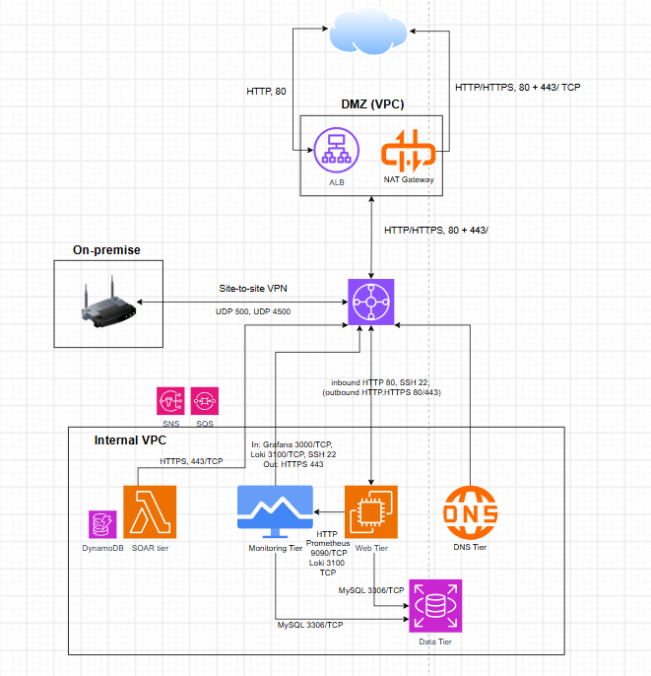

3.2 Design principles
- Least Privilege
- Automation of as much as possible
- Design for failure

3.3 Component overview
Component | Service / product | Location | Purpose
Load balancer | Application Load Balancer | DMZ VPC | Public entry point for the website
Web servers | EC2 (Ubuntu 24.04, nginx) in an ASG | Internal VPC, web subnets | Serve the website
Database | RDS MySQL 8.4 | Internal VPC, data subnets | Application data
Private DNS | Route 53 private zone + forwarders | Internal VPC, DNS subnets | Name resolution across sites
Monitoring | Prometheus, Loki, Grafana | Internal VPC, monitoring subnet | Metrics, logs, alerts
SOAR | SNS, SQS, Lambda, DynamoDB | Internal VPC, SOAR subnets | Automated response to alerts
Firewall / VPN | pfSense | On-premises (VMware) | Perimeter firewall and VPN endpoint
Configuration management | Ansible | On-premises management network | Automated, repeatable configuration

4 Hybrid network design

4.1 Address plan
Name | CIDR | AZ | Purpose
vpc-dmz | 10.0.1.0/24 | - | DMZ VPC
dmz_public_a / _b | 10.0.1.0/26, 10.0.1.64/26 | 1a / 1b | ALB
nat | 10.0.1.128/26 | 1a | NAT gateway
dmz TGW subnets | 10.0.1.192/28, 10.0.1.208/28 | 1a / 1b | Transit Gateway attachment
internal_vpc | 10.0.2.0/23 | - | Internal VPC
web_a / web_b | 10.0.2.0/26, 10.0.2.64/26 | 1a / 1b | Web servers
monitoring | 10.0.2.128/26 | 1a | Monitoring and management
data_a / data_b | 10.0.2.192/27, 10.0.2.224/27 | 1a / 1b | RDS
soar_a / soar_b | 10.0.3.0/27, 10.0.3.32/27 | 1a / 1b | SOAR Lambda
dns_a / dns_b | 10.0.3.64/28, 10.0.3.80/28 | 1a / 1b | DNS forwarders
internal TGW subnets | 10.0.3.96/28, 10.0.3.112/28 | 1a / 1b | Transit Gateway attachment
Spare | 10.0.3.128/25 | - | Reserved for growth
On-prem networks | 192.168.10.0/24 - 192.168.40.0/24 | - | On-prem environment

4.2 Segmentation
The network is split into two VPCs because of how much certain parts of the architecture need to be exposed to the internet. The DMZ VPC is the only part of the network that touches the internet and it holds the Application Load Balancer and the NAT Gateway, which contain no sensitive data. The internal VPC on the other hand hold everything that must stay private and has no direct public access. The two VPCs are using a Transit Gateway so all the traffic in between them and the on premise environment passes through a single hub, hence fulfilling the hub-to-spoke requirement. Outbound internet access from the internal VPC passes through the TGW to the DMZ to the NAT Gateway and ensure that instances can start connections to the internet, but not the internet to them. Each tier has it’s own subnets for clear security boundaries, readability and availability through using different AZ.
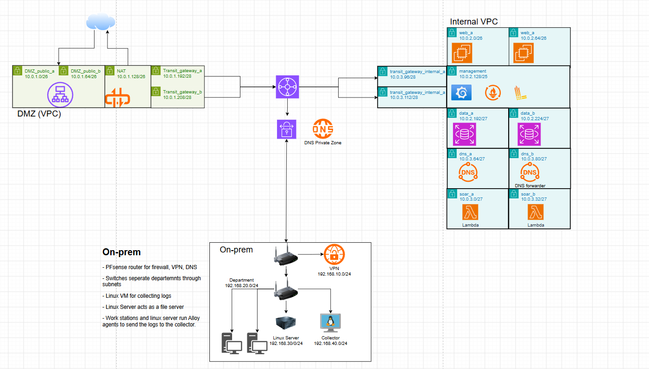

4.3 Site-to-site VPN
Parameter | Value
AWS side | Site-to-Site VPN attached to the Transit Gateway
Customer gateway | 192.168.10.254
On-prem device | pfSense <version>
Routing | Static routes
Tunnels | 2 (one per AWS endpoint)

4.4 Routing
Route table | Destination | Target | Reason
Internal VPC (default) | 0.0.0.0/0 | Transit Gateway | All traffic leaves via the hub
DMZ public | 0.0.0.0/0 | Internet gateway | Public access for the ALB
DMZ public | 10.0.2.0/23 | Transit Gateway | ALB to web servers
DMZ TGW subnets | 0.0.0.0/0 | NAT gateway | Internet access for internal VPC
Transit Gateway | 0.0.0.0/0 | DMZ attachment | Default route to NAT
Transit Gateway | 192.168.x.0/24 | VPN attachment | Traffic to on-prem
pfSense | 10.0.0.0/16 | IPsec | Traffic to AWS

4.5 Firewalling
Source | Destination | Port / protocol | Enforced by | Reason
Internet | ALB | 80/TCP | SG alb | Public website
ALB | Web subnets | 80/TCP | SG alb (egress), SG web (ingress) | Forward requests to the web servers
Web servers | RDS | 3306/TCP | SG db (ingress from SG web), SG web (egress) | Application database
Monitoring subnet | RDS | 3306/TCP (MySQL over TLS) | SG db, SG monitoring | Database checks and administration
Web servers | Prometheus | 9090/TCP (HTTP remote write) | SG monitoring, SG web | Metrics from Alloy
Web servers | Loki | 3100/TCP (HTTP) | SG monitoring, SG web | Logs from Alloy
Web, Monitoring | Internet | 80,443/TCP | SG web, SG monitoring (egress) | OS and package updates
Monitoring (Grafana) | AWS APIs(SNS, CloudWatch) | 443/TCP (HTTPS) | SG monitoring | Send alerts to SNS, read CloudWatch metrics
SOAR Lambda | AWS APIs (DynamoDB, Secrets Manager) | 443/TCP (HTTPS) | SG soar | Store incidents. Read the pfSense API key
pfSense WAN | WS VPN endpoints (2 tunnels) | 500/UDP, 4500/UDP | pfSense, AWS VPN | Build the IPsec tunnels
SOAR subnets | pfSense REST API | 443/TCP | SG soar (egress), pfSense rule | Automated block actions
CpfSense resolver | Route 53 Resolver inbound endpoint | 53/UDP/TCP | SG dns-endpoint, pfSense | Resolve internal from on-prem
Collector | Loki | 3100/TCP(HTTP) | pfSense, SG monitoring | Ship on-prem logs to AWS
Ansible control node (192.168.40.0/24) | Web, Monitoring | 22/TCP(SSH) | pfSense, SG web, SG monitoring | Configuration management

4.6 Private DNS

Record | Type | Target | Purpose
database.innovatech.internal | CNAME | RDS endpoint | Database connection name
Grafana.innovatech.internal | A | Monitoring instance IP | Dashboards
loki.innovatech.internal | A | Monitoring instance IP | Log ingesstion
Prometheus.innovatech.internal | A | Monitoring instance IP | Metrics ingestion

5 Application and data tiers

5.1 Web tier
The website runs on Ubuntu web servers in the internal VPC. The only way in is a public Application Load Balancer (ALB) in the DMZ VPC. Every part of the tier is defined in Terraform, so a web server is never configured by hand and can be replaced at any time.

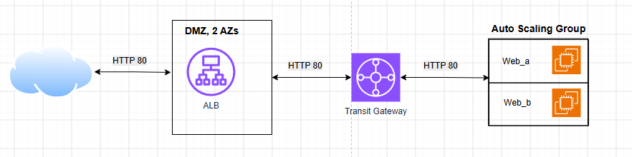5.2 Data tier
Setting | Value | Reason
Engine | MySQL 8.4 | Newest available version
Instance class | db.t4g.micro | Smallest, cheapest
Storage | 20 GB gp3, encrypted | Minimum size, encryption at rest
High availability | Multi-AZ standby | automatic failover
Credentials | Secrets Manager (managed master password) | No password in code
Transport | require_secure_transport = 1 | TLS enforced
Backups | 7 days, 03:00-04:00 | Picked at random

6 Monitoring solution

Overview
The environment and its on-premises parts are monitored centrally with the Prometheus + Loki + Grafana (PLG) stack:
- Prometheus stores metrics.
- Loki stores logs.
- Grafana provides dashboards and alerting in one place for both sites.
- Grafana Alloy is the agent on every host; it collects metrics and logs and pushes them to Prometheus and Loki.
- CloudWatch is added as a Grafana data source for the AWS managed services (ALB, RDS, Lambda, SQS), which can't run an agent.

6.2 Data flow
Webservers:
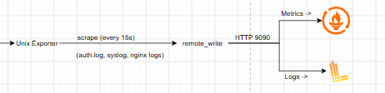
On-premise: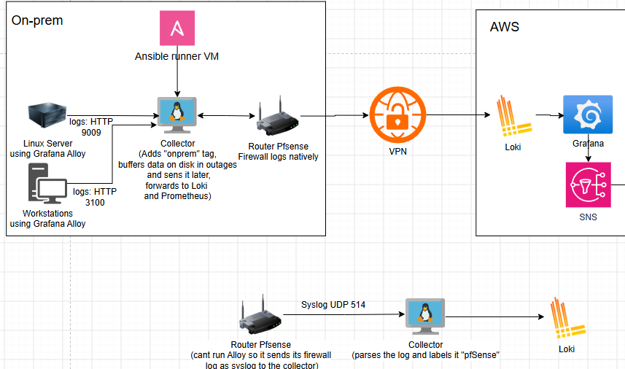

7 SOAR system

7.1 Overview
Grafana creates an Alert, which SNS receives. It forwards it to SQS, which puts the alert in queue and buffering it in case of outage. Lambda picks up the alert and tries to take action. If it fails the alert goes back to the queue after a short interval it retries. If it succeeds the incident is recorded in a DynamoDB, the attacker IP is blocked, an email is sent to inform of the accident and a CloudWatch report on the response is created.

7.2 Architecture and flow
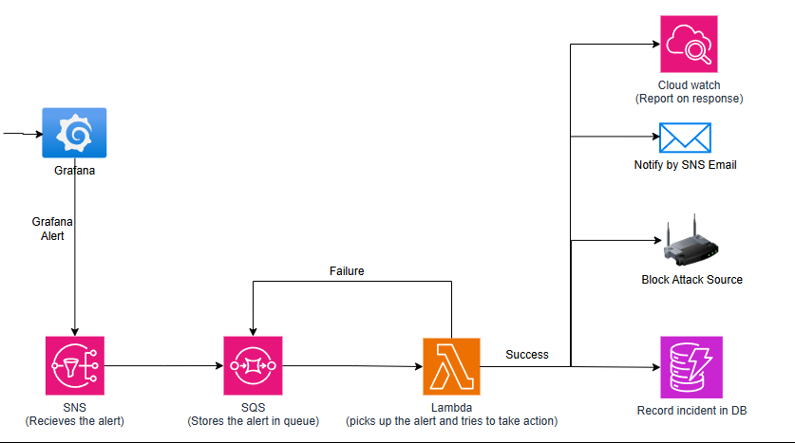

7.3 SOAR Security

Aspect | Design
Seperate platform | The SOAR runs serverless on AWS, the monitored workstations and servers run on-premise, therefore a compromised workstation has no access to the platform where the SOAR runs on.
Network | No inbound access to the SOAR subnets, outbound 443/HTTPS to pfSense and the AWS APIs
Encryption | SNS, SQS and DynamoDB are encrypted at rest
Secrets | The pfSense API key should be stored in Secrets Manager

8 Security design

8.1 Identity and access
[SSO for administrators, OIDC role for the pipeline, least-privilege roles for Lambda and EC2.]
Principal | Permissions | Justification
Pipeline (github-actions-terraform) | AdministratorAccess | Terraform creates every resource type in the project. The trust policy accepts only tokens from this repository's main branch, so other branches, forks and repositories can't assume the role
Registration Lambda | Register/Deregister targets, CompleteLifecycleAction | Only what registration needs
SOAR Lambda | Lambda execution role | Limits the damage if the role is abused
Web servers | Read only the database secret | No credentials saved on the disk
Grafana | Read-only to CloudWatch | No access keys in Grafana

8.2 Encryption
Data | At rest | In transit
Terraform state | S3 SSE | HTTPS
Database | RDS encryption | TLS required
Site-to-site traffic | - | IPsec
<data> | <at rest> | <in transit>

8.3 Defence in depth
[Layers from outside in: ALB, security groups, NACLs, private subnets, pfSense, host hardening, monitoring, automated response.]

8.4 Secrets management
[Where secrets live (Secrets Manager), who can read them and how they rotate.]

9 Infrastructure as Code and pipeline

9.1 Terraform structure
Module | Contents
network | VPCs, subnets, gateways, Transit Gateway, routing
dns | Private hosted zone <and forwarders>
web | ALB, ASG, launch template, registration Lambda
data | RDS, subnet group, parameter group, DB security group
vpn | <Customer gateway, VPN connection, TGW routes>
monitoring | <...>
soar | <...>

9.2 State and locking
[S3 backend with native lock file, created by a separate bootstrap configuration.]

9.3 CI/CD pipeline
[GitHub Actions: fmt, validate, plan on pull request; apply on main. Authentication via OIDC, no stored keys.]
[Insert diagram here]
Figure 6: Pipeline flow

10 Resilience and design for failure
[For each failure: what breaks, what keeps working, how recovery happens, and the result of the test you ran.]
Failure | Impact | Mitigation | Recovery | Tested? / result
Web instance terminated | <Half capacity> | ASG in two AZs | ASG replaces it, Lambda registers it | <date, result, evidence>
Primary DB failure | <Short outage> | <Multi-AZ standby> | <Automatic failover> | <result>
One VPN tunnel down | <None> | Two tunnels | Traffic moves to second tunnel | <result>
One availability zone lost | <Half of web, DNS, SOAR> | Two subnets per tier | <Automatic> | <result>
SOAR action fails | <Block not applied> | SQS retries, DLQ | <Manual review of DLQ> | <result>

11 Risks and limitations
Risk / limitation | Likelihood | Impact | Mitigation
<Home public IP changes> | <Medium> | <VPN down> | <Update customer gateway>
<Sandbox account limits> | <Low> | <Deployment blocked> | <mitigation>
<Laptop RAM limits on-prem lab size> | <High> | <Fewer VMs> | <Linked clones, minimal VMs>

